EF Core 6/7 - SQL Server Interceptor for Large Contains Clause (100K+ Values)
Bert O’Neill
Department: | Version 1 - IT\Software Support
Document Title: | EF Core 6\7 Contains to OpenJson (SQL Server) - User Guide
Author: | Bert O’Neill
Date: | 24-May-2024
Version | 1.0
Email | Bert.ONeill@Version1.com
Document Goals | Provide an overview for developers, on how to quickly configure their Entity Framework Core 6 or 7 settings, to take advantage of a new feature currently added to EF Core 8 – using TSQL’s OpenJson command against SQL Server for large IN clauses.

Revision History

Date | Version | Description | Author
24-May-2024 | 1.0 | Initial draft | Bert O’Neill

Contents
Revision History 1
Introduction 3
Purpose 3
Scope 3
Prerequisites 3
Blog Files 3
SQL Script 3
Visual Studio Solution (Projects x3) 3
EF Core Interceptor Class 3
Setting Up Test Database 4
Benchmarks (Seconds) 5
Add Interceptor Using NuGet Package OR Add Class Directly int Your Project 6
Add Interceptor Class Uinsg NuGet Package 6
Add Interceptor Class Directly 8
Edit Entity Framework Core Settings to Call Custom Interceptor Middleware 9
Interceptor Code Explanation 9
ReaderExecutingAsync | ReaderExecuting 9
Helper Classes 9
Example SQL Syntax Generated 9
Original EF Core SQL Syntax Generated (EFC 6\7) 9
New EF Core SQL Syntax Generated (EFC 6\7) 9
Miscellaneous 9
Acronym 9

Introduction
This document provides an overview on how to configure your Entity Framework Core (6 or 7) settings to take advantage of the performance gains that OpenJson provides when using a large SQL IN clause of values.

Purpose
Your project maybe in a situation, where you now need to scale up and query more data using your cached values. But if you are not able to take advantage of EF Core 8, as the migration will entail more testing and development for your team – you have the ability to avail of OpenJson while still using EF Core 6 or 7 with this NuGet Package or directly incorporating the class into your codebase.

Scope
The scope of this document is to convey the configuration steps needed to start using OpenJson with EF Core 6\7.

Prerequisites
- An understanding of (Microsoft’s) TSQL
- An understanding of (Microsoft’s) Entity Framework Core
- An understanding of (Microsoft’s) Visual Studio or Visual Code
- An understanding of EF Core’s Pipeline & Interceptors
- An understanding on how to install NuGet Packages
- Have SQL Server (Developer Edition) installed.
- Have SSMS installed
- Have Visual Studio 22 Community installed.

Blog Files

SQL Script

Visual Studio Solution (Projects x3)

EF Core Interceptor Class

Setting up Test Database
Run the following SQL script to:
- Create a new test database called LinqPerformanceDemo
- Create a new table called LargeTable
- Insert 1 million records into the table LargeTable
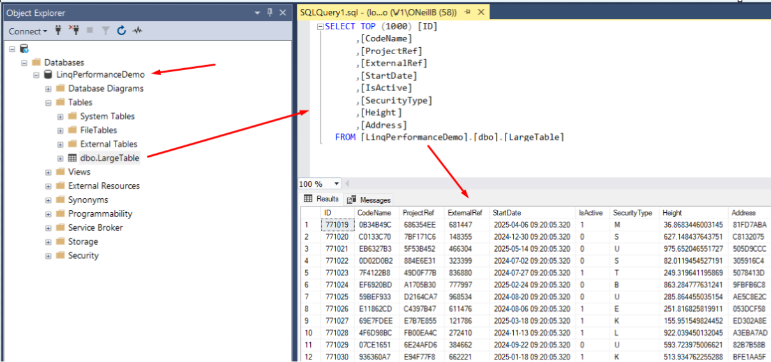

Benchmarks (Seconds)
Using a simple LINQ statement with a large IN clause and a small NOT IN Clause:
context.LargeTables.Where(itm => chunkData.Contains(itm.CodeName) && !_listNotIn.Contains(itm.ProjectRef)).ToListAsync();

In Clause - Batch Size | Standard EF Settings | OpenJson EF Interceptor
20K | 151 | 234
30K | 396 | 157
40K | Timeout | 132
100K | Timeout | 123
150K | Timeout | 99
200K | Timeout | 98
300k | Timeout | 91
500k | Timeout | 83
700K | Timeout | 86
1M | Timeout | 105

At 40K, standard EF failed with a timeout on the first IN clause:
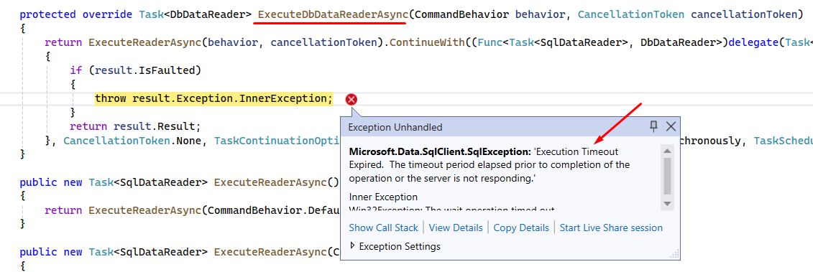
NB: The Entity Framework SQL query generator will very often create SQL statements that are complex and convoluted, especially when there is an IN\NOT IN clause involved. It will duplicate the clause with any joined tables that need to match on your values. This can often make the query fail, as SQL Server is unable to execute it, due to its complexity. But with OpenJson you can get around that issue – by using a larger number of values within your chunking approach, and multithreading with concurrent bags to maintain your results (I’ll show example code later).

Add Interceptor Using NuGet Package OR Add Class Directly into Your Project

Add Interceptor Class Uinsg NuGet Package
The NuGet package is located here on Nuget.Org, with the User Guide on how to edit the EF settings within your project.
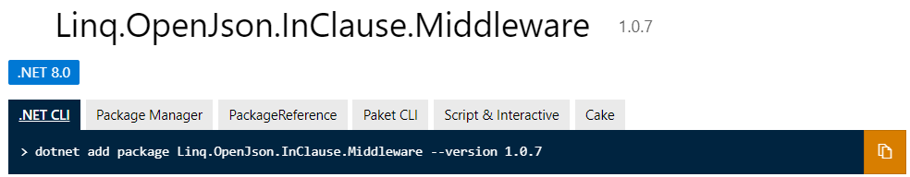
You can add the NuGet package within Visual Studio like a normal package, into your project – search for Linq.OpenJson.InClause.Middleware and click install.
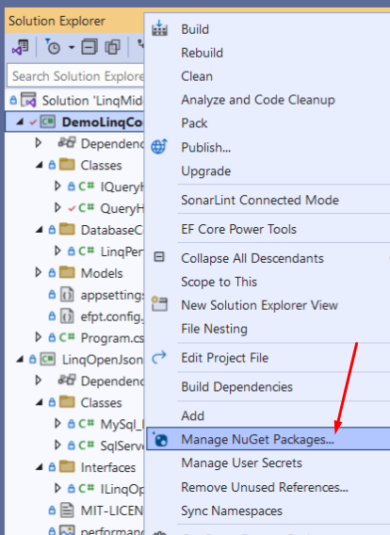

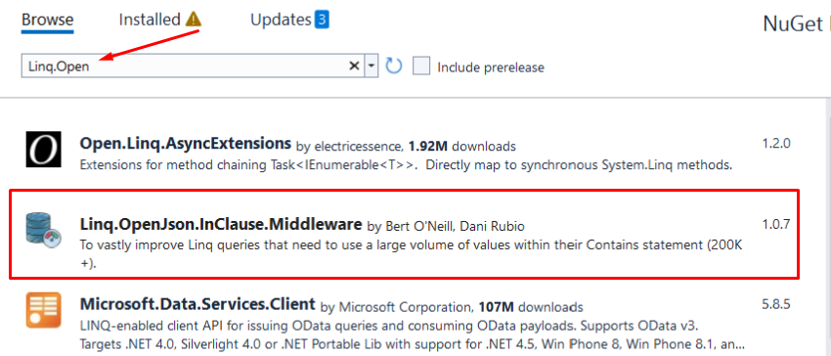

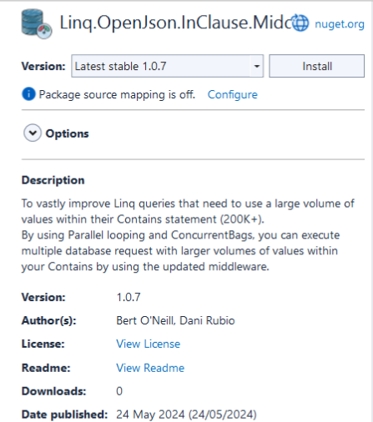

Add Interceptor Class Directly
If you open the attached Visual Studio solution you will see three projects, the project named DemoLinqContainsOpenJson is to demo and test the new EF interceptor.
The second project called LinqOpenJsonInClauseMiddleware, is the NuGet package contents and contains the interceptor override methods (ReaderExecutingAsync and ReaderExecuting).
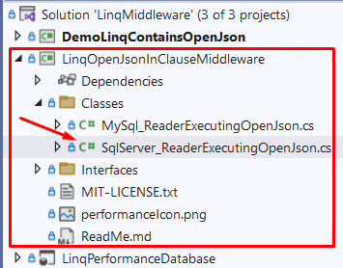
If you want to customise the code, for example increase the chunking limit, you can do this in the SqlServerReaderExecutingOpenJson class, by setting the constant MINIMUM_ITEM_SIZE.
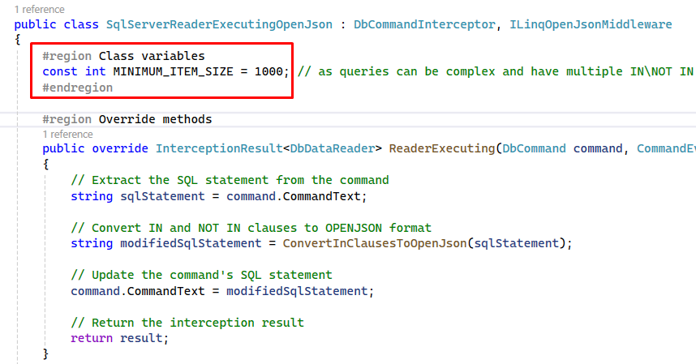
To integrate the SqlServerReaderExecutingOpenJson class into your project, simply copy the class form the LinqOpenJsonInClauseMiddleware project, renaming the Namespace in the class to match your project Namespace. Then, you can edit the SQL that gets generated to match your needs.

Edit Entity Framework Core Settings to Call Custom Interceptor Middleware

Interceptor Code Explanation

ReaderExecutingAsync | ReaderExecuting
In the override method below, you can see we intercept the SQL that is generated by LINQ and replace it with our OpenJson alternative SQL statement. We call out helper method ConvertInClauseToOpenJson.
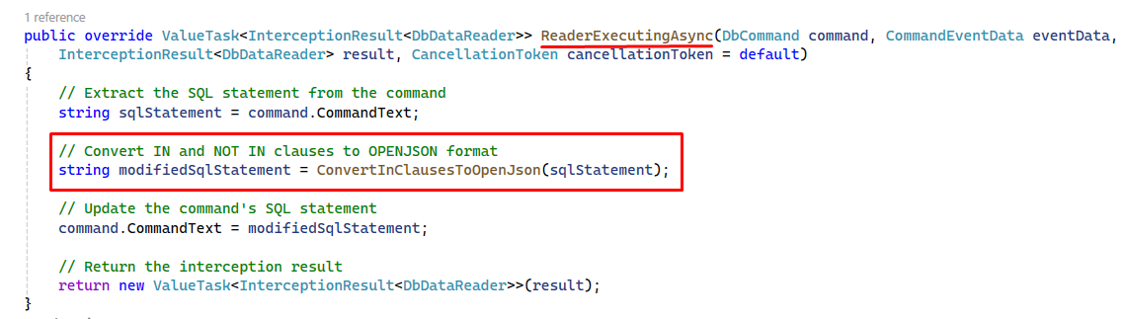

Helper Classes
The ConvertInClauseToOpenJson method will parse out the IN\NOT IN clauses and then pass the values onto the ConvertToOpenJson method that will replace the existing SQL with the OpenJson SQL.
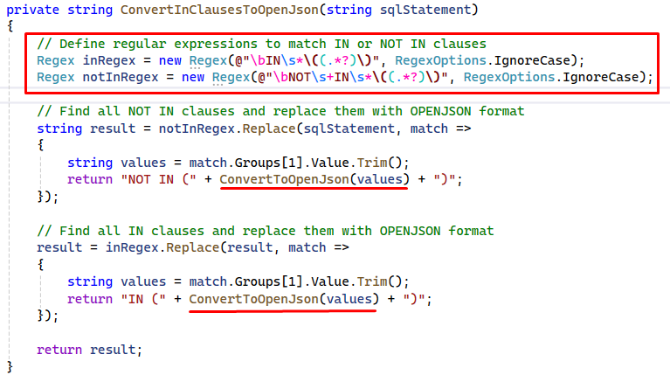

The ConvertToOpenJson method will then determine if the values within the IN\NOT IN clause are integers\decimals or varchar related and build up the new OpenJson SQL related to that.
You can finally see the OpenJson statement being inserted to the SQL statement and returned to the parent IN\NOT IN clause.
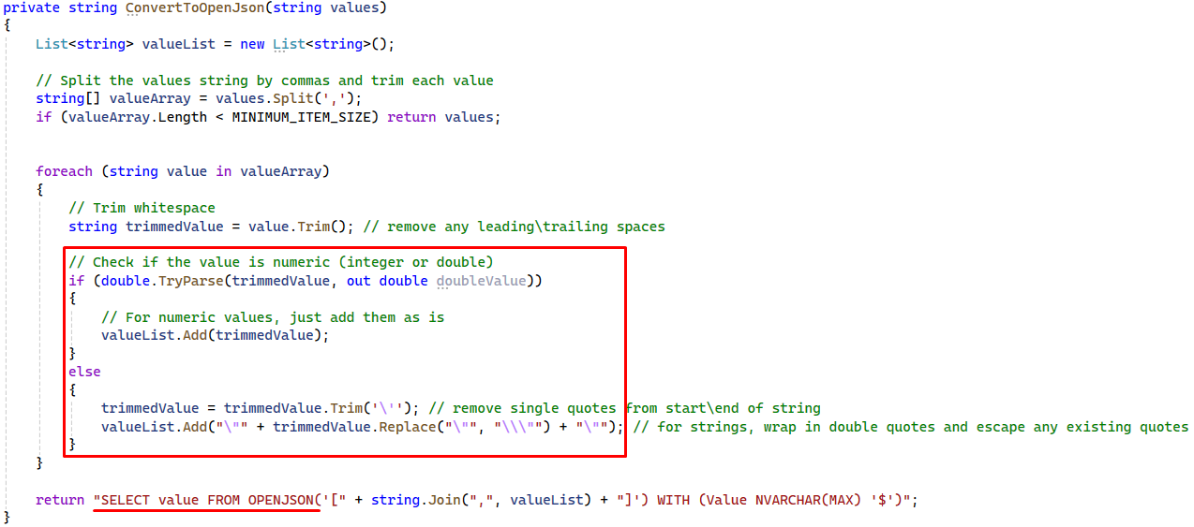

Example of Original SQL and OpenJson SQL Generated
In the (slimmed down values) original SQL, you can see a standard IN clause and its values.
Then in the OpenJson generated SQL, you can see that the values are string related and that the OpenJson has correctly used the associated NVARCHAR datatype.
NB: The NOT IN clause didn’t get converted to OpenJson as the value count was less than 1k.

Varchar
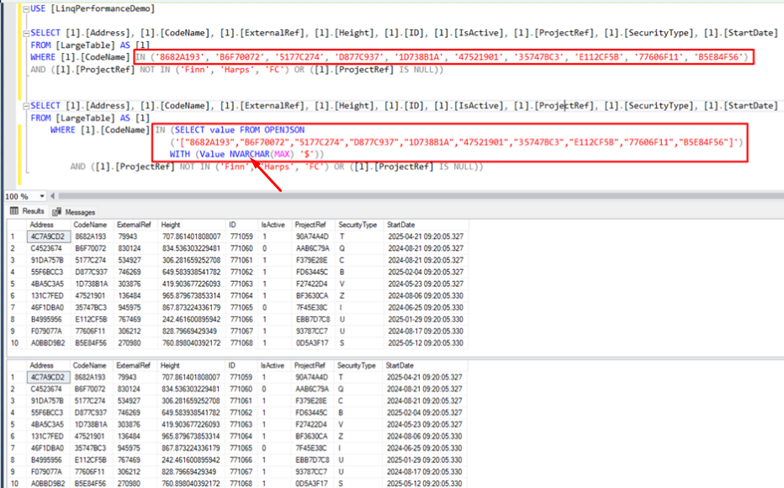

Integer
Below, you can see the equivalent for Integer related values within the IN clause, and the correct OpenJson datatype (Int) is associated with the query.
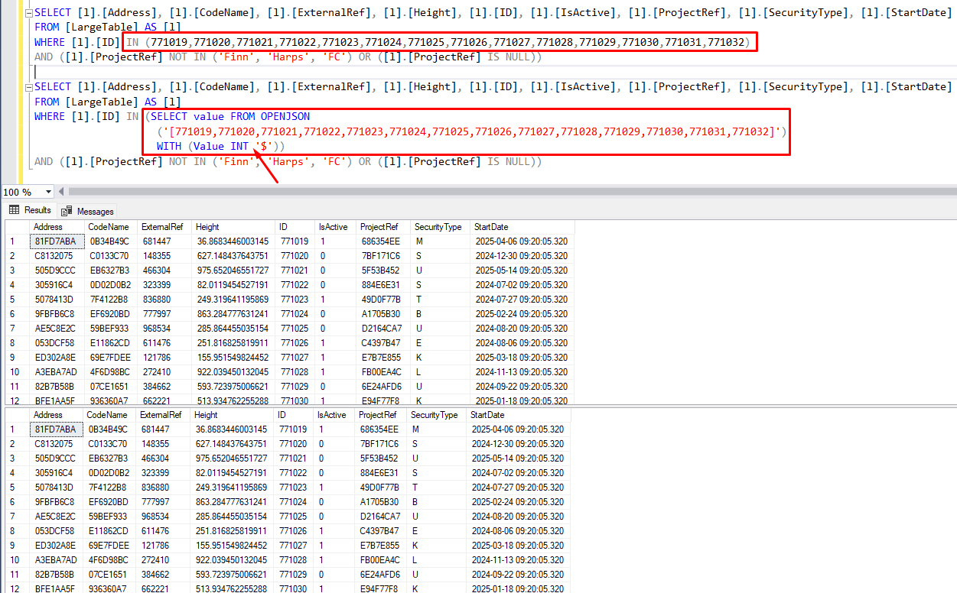

Original EF Core SQL Syntax Generated (EFC 6\7)

New EF Core SQL Syntax Generated (EFC 6\7)

Miscellaneous

Acronym
Abbreviation | Meaning
EF | Entity Framework
EFC | Entity Framework Core
SQL | Structured Query Language
TSQL | Transact Structured Query Language

